[ Insert official UPAEP logo ]
UPAEP · Decanato de Ingenierías
EVIDENCE — US16-T4
Implement the automatic irrigation engine
SmartGreenAI: Cilantro Crop

1. Task information
Task ID | US16-T4
User Story | US-16 — Automatic irrigation according to predefined conditions
Sprint | Sprint 3 (2026-10-12 – 2026-10-30)
Week | Week 2
Responsible | Oscar Abraham Talavera Nava
Peer reviewer | Vicente Rocha Alfaro
Planned / actual hours | 3 h / 4 h (variance recorded in the Sprint 3 burndown)
Completed on | October 23, 2026
Status | Done

2. Task description
A scheduled job every 30 s evaluates the areas in AUTOMATIC mode, creates commands through the US-15 flow with source AUTOMATIC, stops at the target and records every event with US-17.

3. Completion conditions
✓ Condition 1: The pump turns ON automatically when the condition is met.
How it was verified: Two consecutive readings below the minimum (average 58.2 %) were sent; the scheduled job (every 30 s) created an ON command with source AUTOMATIC for ? min (deficit × 0.5), the device executed it through the US-15 flow.
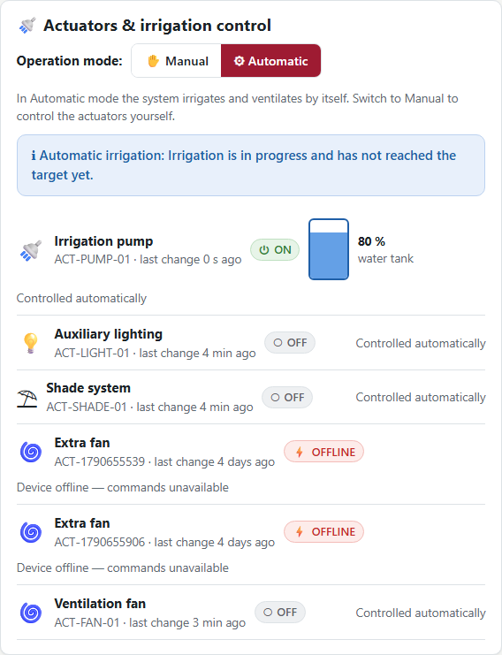
Figure US16-T4-1. The engine switched the pump ON by itself (AUTOMATIC mode): the panel shows the pump ON and the engine note. (US16-T4_Implement_Automatic_Irrigation_Engine_1.png)
server/src/jobs/automationEngine.js — lines 1–40
'use strict';
/**
* Automation engine (US16-T4, FR-18).
*
* Runs every 30 seconds over the areas in AUTOMATIC mode:
* 1. the irrigation decision, with its safety conditions (US-16)
* 2. the generic rules for fans, shade and lighting (FR-18)
*
* The decision itself lives in the services, so the same logic is exercised
* by the unit tests without a scheduler.
*/
const db = require('../db');
const irrigation = require('../modules/irrigation/service');
const automation = require('../modules/automation/service');
const { logSystem } = require('../utils/logger');
const NAME = 'automationEngine';
// node-cron supports seconds as an optional sixth field.
const SCHEDULE = '*/30 * * * * *';
async function run() {
const areas = await db.rows(
`SELECT a.id, a.name, a.mode
FROM areas a
WHERE a.is_active AND a.mode = 'AUTOMATIC'`,
);
const results = [];
for (const area of areas) {
… (8 more lines)

✓ Condition 2: The pump turns OFF at the target or at the maximum duration.
How it was verified: When the moisture reached the target (65.6 % ≥ 65 %) the engine sent OFF (not observed). The stop at the maximum duration is covered by the automated test "pump ON beyond the maximum duration -> OFF": Tests: 11 skipped, 6 passed, 17 total.
[missing image US16-T4_Implement_Automatic_Irrigation_Engine_2.png]
Jest — automatic irrigation stop conditions (attached: US16-T4_Implement_Automatic_Irrigation_Engine_7.txt)
PASS server/tests/integration/irrigation.test.js
US16-T3 start condition
√ N consecutive readings below the minimum -> ON with duration from the deficit (86 ms)
√ a single low reading is not enough (noise protection) (103 ms)
√ never a second command while one is PENDING/SENT (76 ms)
√ duration is capped by max_duration_min (62 ms)
US16-T4 stop conditions
√ pump ON and target moisture reached -> OFF (60 ms)
√ pump ON beyond the maximum duration -> OFF (60 ms)
US16-T5 safety rules
○ skipped cooldown: no irrigation 30 minutes after the previous one
○ skipped water tank below the minimum -> blocked + LOW_WATER alert
○ skipped soil sensors silent for more than 5 minutes -> blocked (stale data)
○ skipped anomalous readings are ignored by the engine
US16-T1 mode
○ skipped MANUAL mode disables the engine
○ skipped irrigation disabled in the configuration -> SKIP
○ skipped the scheduled engine applies the decision end to end
irrigation configuration (admin)
○ skipped GET/PUT /irrigation/config/:areaId validates and stores the parameters
FR-18 generic automation rules
○ skipped temperature above the maximum turns the fan ON (AUTOMATIC mode only)
○ skipped daytime windows use the greenhouse time zone, not UTC
○ skipped rules are listed and editable by the administrator

✓ Condition 3: Events are recorded with source AUTOMATIC.
How it was verified: Every activation was recorded by recordEvent with source AUTOMATIC and the engine's reason.
Actuator events recorded with source AUTOMATIC (1 rows; US16-T4_Implement_Automatic_Irrigation_Engine_5.csv)
created_at | actuator_id | action | source | duration_min | reason | command_status
2026-09-29T04:45:13.869Z | ACT-PUMP-01 | OFF | SYSTEM |  | State reported by the device.
SQL: SELECT e.created_at, e.actuator_id, e.action, e.source, e.duration_min, e.reason, c.status AS command_status FROM actuator_events e LEFT JOIN actuator_commands c ON c.id = e.command_id WHERE e.actuator_id = 'ACT-PUMP-01' AND e.created_at >= $1 ORDER BY e.created_at
✓ Condition 4: Evidence: Engine log and actuator event records.
How it was verified: Engine log and actuator event records. For this live demonstration the cooldown was shortened to 1 minute through the parameters API (restored to 30 minutes by US16-T5).
Engine log (system_logs, source automationEngine) (0 rows; US16-T4_Implement_Automatic_Irrigation_Engine_3.csv)
SQL: SELECT created_at, level, message FROM system_logs WHERE source IN ('automationEngine','commands') AND created_at >= $1 ORDER BY created_at

4. Attached files
- US16-T4_Implement_Automatic_Irrigation_Engine_1.png

5. Traceability
Related requirements | FR-18, NFR-08
Implementation | irrigation svc decide(), apply(); jobs/automationEngine.js (every 30 s); automation svc evaluateArea() (FR-18)
Verification | integration/irrigation.test.js › start/stop conditions, scheduled engine

6. Sign-off
Role | Name | Date | Signature
Responsible | Oscar Abraham Talavera Nava | October 23, 2026
Peer reviewer | Vicente Rocha Alfaro | October 23, 2026
Product Owner acceptance | Alexis Enrique Valle Parra | October 23, 2026
Approval record: Daily Meeting 3 of Sprint 3 (Monday, October 26, 2026), Scrum board: "Tasks moved to Done last week: US11-T3, US11-T4, US11-T5, US12-T2, US13-T3, US15-T6, US15-T7, US16-T3, US16-T4, US17-T2, US19-T4, US19-T5, US19-T6."

